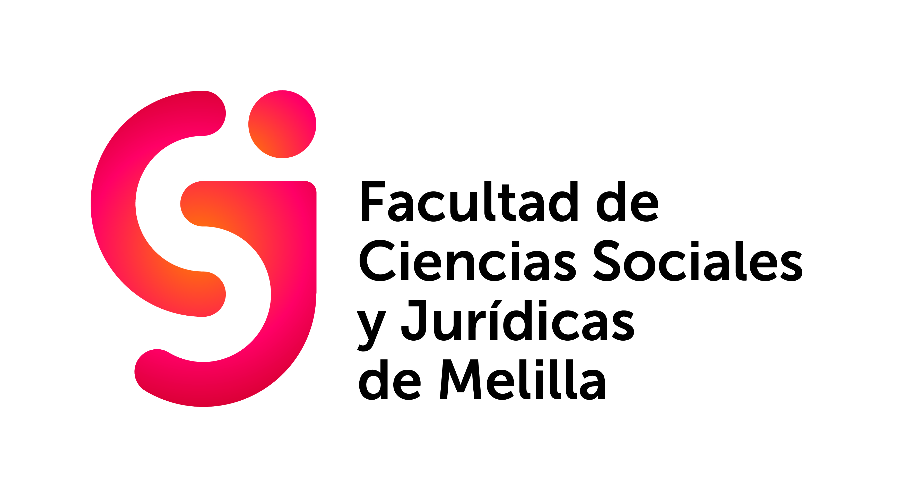
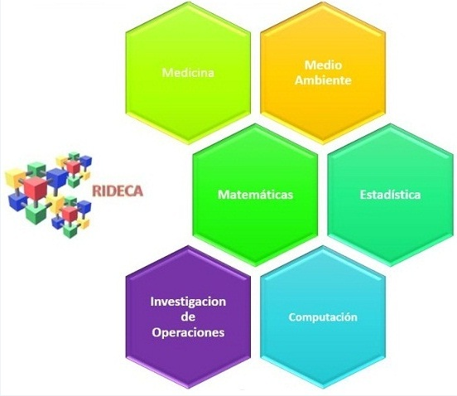

Presentation
Dear friends and colleagues:
We are pleased to welcome you in the name of the Ibero-American Network of Applied Quantitative Studies (RIDECA), the Organizing Committee, the Faculty of Social Science and Law of the University of Granada and in my own, to the IX Ibero-American Operational Research Workshop, to be held at the Kursaal Theater in Melilla on September 25-27, 2019, coinciding with the 40th anniversary of the establishment of the Faculty. This workshop aims to be a meeting point between all professionals who are dedicated to Operational Research.
The scientific program of the meeting aims to reflect the most relevant aspects and the latest results obtained in six major areas, as agreed at the last meeting of RIDECA held last March in Havana:

Statistic and probability. Optimization.
Mathematical and Environmental Economy.
Operations research.
Big Data.
Entrepreneurship and Social Innovation. Smart cities.
Teaching and learning of Statistics and Operational Research.

As usual, oral communication and poster sessions covering the entire spectrum of the six areas indicated will have place within next edition.
It will be a pleasure to have your presence. In the name of the organizing and scientific committee we hope you find it interesting and that your attendance and participation in the meeting contribute to the success of it.
The website of the workshop will soon be available with more information about it (program, registration, sending of communications, etc.).
We wait for you all in Melilla, and we remain as always at your disposal.
Yours sincerely.
Juan Antonio Marmolejo Martín
President of the Organizing Committee

