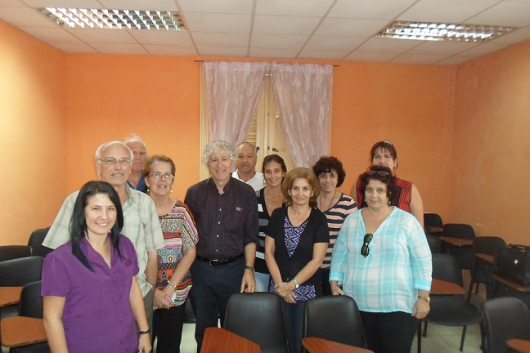The 29th of November Alan Agresti (Distinguished Professor Emeritus of University of Florida) visited the Group of Probability and Statistics of Universidad de La Habana. Prof. Vivian Sistachs chaired the seminar. The theme was Some Perspectives about Generalized Linear Modeling. During the talk were discussed several topics pertaining to generalized linear modeling. With focus on categorical data, the topics include (1) bias in using ordinary linear models with ordinal categorical response data, (2) interpreting effects with nonlinear link functions, (3) cautions in using Wald inference (tests and confidence intervals) when effects are large or ear the boundary of the parameter space, and (4) the behavior and choice of residuals for GLMs.

We were very glad receiving Prof. Agresti and having his interesting talk
Previously the group organized, some years ago, a workshop with a group of statisticians from USA, headed by Marie Davidian. Prof. James Cochran and Chris Baker have visited our group too.
The group is ruling a MSc in Biostatistics (Headed by prof S. Sistachs) and a MSc in Probability and Statistics (Headed by prof C. Bouza) and Alan´s books are used in the teaching of Categorical Data Analysis

